Instructions for email signatures:
- Type in the search bar in outlook: Signatures
- Select signatures
- Highlight the signature that you want to change
- Underneath edit signature – scroll to the bottom of the current signature and then select the image button
- 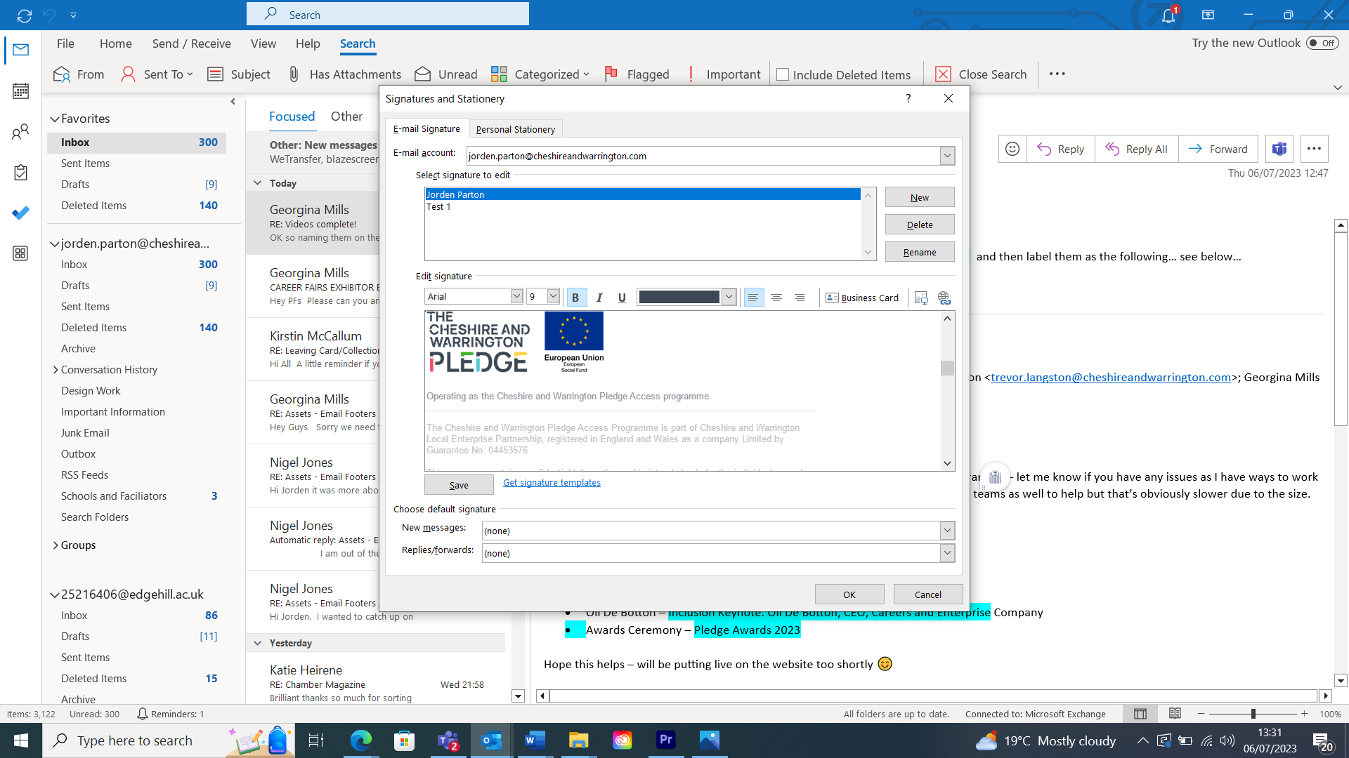
- Add the image
- 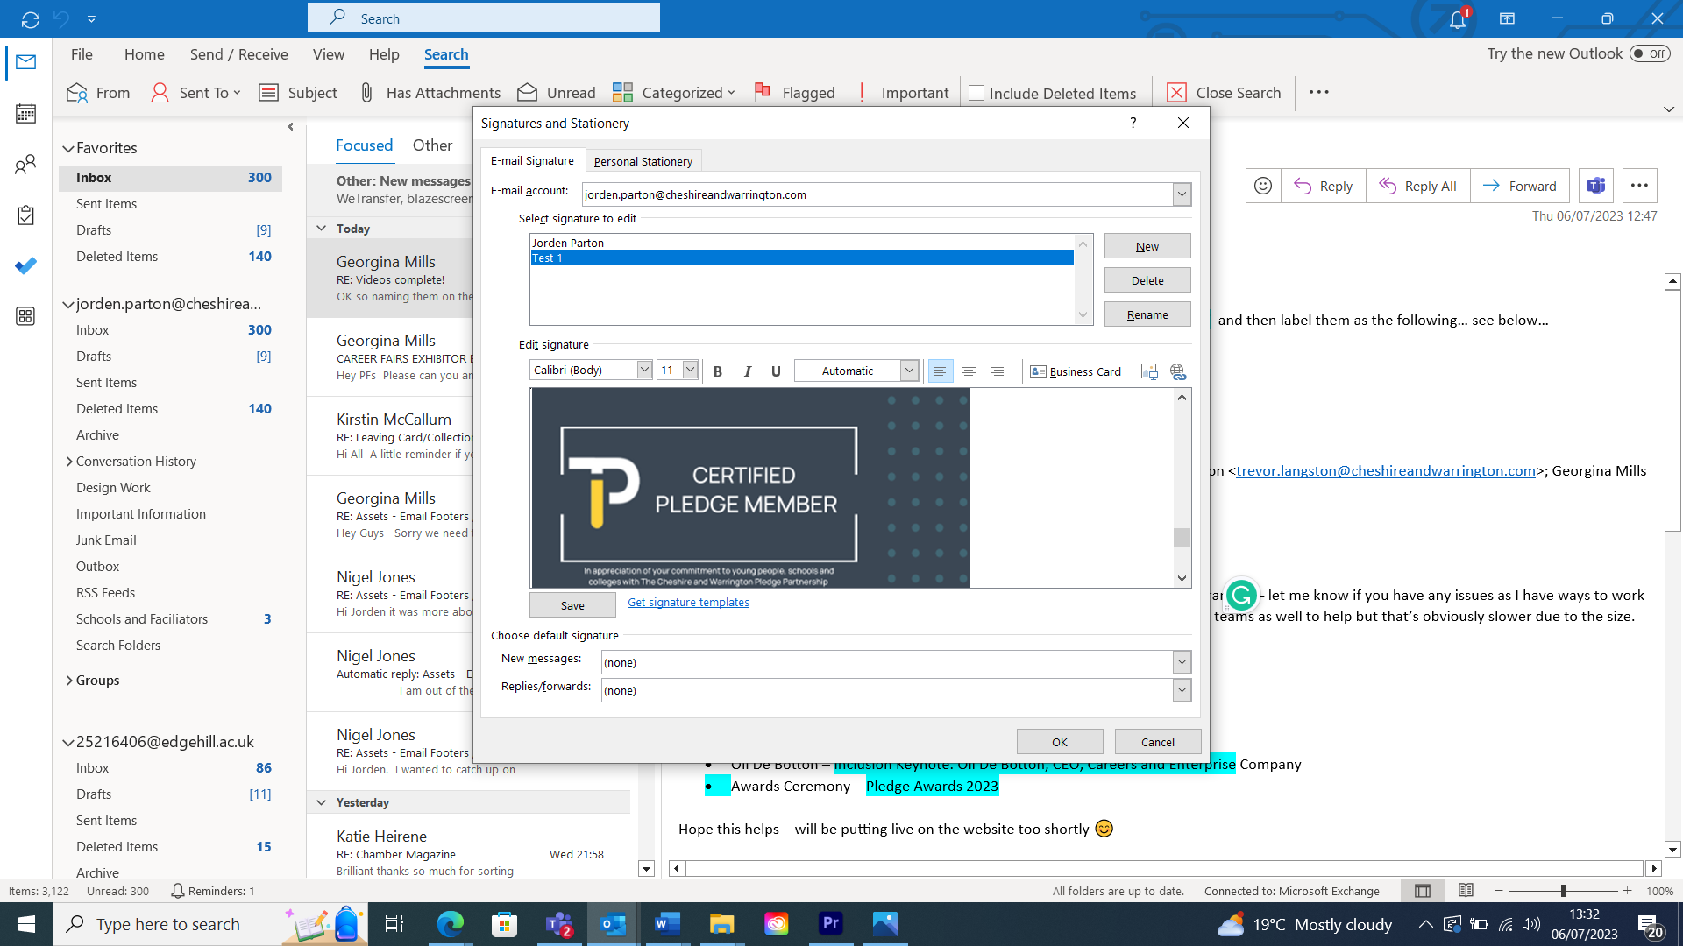
- Press OK
- Select Signature:
- 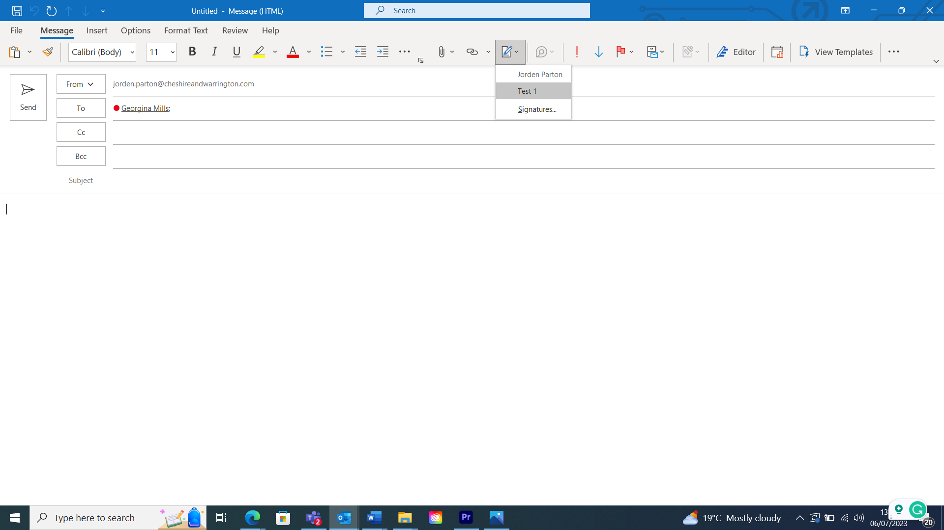
- End result:
